MINUTES OF THE REGULAR MEETING OF THE BOARD OF ZONING APPEALS BRENTWOOD, TENNESSEE

The Brentwood Board of Zoning Appeals (BZA) met in a regularly scheduled session on July 18, 2022 at 5:30 p.m. in the Brentwood Municipal Center.

Present were Todd Lockhart, Lisa Rothman, Eric Hauch, and Louie Escobedo. The staff members present were Todd Petrowski and Allison Roberts.

Mr. Hauch made a motion to approve the June 20, 2022 minutes. Ms. Rothman seconded the motion; approval was 4-0.

ITEM 1:

BZA2206-003 Accessory Structure Request – McGavock Farms, Section 2, Lot 12, 615 Post Oak Circle – Zoned OSRD

Representative: Westerly Construction Company

PROJECT SUMMARY:

Westerly Construction Company, Inc. requests of a 625 square foot detached structure to be constructed in the rear buildable area of the lot. The structure will be constructed of painted white brick with wood framing. The structure will have a shingle roof that will match the house.

CONDITIONS OF APPROVAL

The department recommends that the following 4 requirements be attached to the approval of the request:

- Any changes to the building or site plans will require staff review and re-approval from the Board of Zoning Appeals prior to issuance of a building permit.

- Complete plans shall be submitted for review, approval, and issuance of a building permit.

- Except on parcels of three or more acres in size, no accessory building shall be designed and/or used for living quarters or sleeping quarters. If proposed, this would require a separate BZA review and approval.

- Accessory structures cannot be used for home occupation/commercial purposes.

Recommendation:

Staff recommends approval of the detached accessory structure, subject to all building codes and staff notes.
A motion to approve was made by Mr. Escobedo. Ms. Rothman seconded the motion; approval was 4-0.

The meeting was adjourned at 5:40pm.

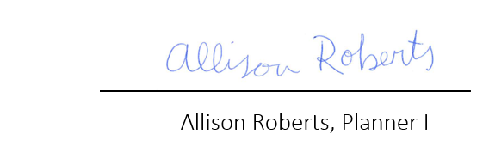

APPROVED: 08/15/2022

